Minutes of Meeting for the Public Hearing Event to inform citizens and stakeholders about the activities for construction of a new kindergarten and the document "Initial Limited Environmental Impact Assessment and Social Aspects for Construction of a New Kindergarten" in settlement Josifovo, Valandovo Municipality held on 27.12.2019
Timetable
- Presentation of the “Social Services Improvement Project” by Marija Maliminovska
- Presentation of "Basic Project for Construction of Kindergarten" by Marija Maliminovska
- Presentation of “Initial Limited Environmental and Social Impact Assessment for New Kindergarten Construction” by Slavjanka Pejchinovska Andonova
- Questions and answers
- Other
The invitation for the public hearing as well as relevant documents were posted on the website of the Ministry of Labor and Social Policy http://www.mtsp.gov.mk/proekt-za-podobruvanje-na-socijalnite-uslugi.nspx and on the website of the Municipality of Valandovo http://www.valandovo.gov.mk/%D0%9E%D0%BF%D1%88%D1%82%D0%B8%D0%BD%D0%B8/%D0%9E%D0%BF%D1%88%D1%82%D0%B8%D0%BD%D0%B0/%D0%9B%D0%BE%D0%BA%D0%B0%D0%BB%D0%BD%D0%B0_%D1%81%D0%B0%D0%BC%D0%BE%D1%83%D0%BF%D1%80%D0%B0%D0%B2%D0%B0/%D0%B8%D0%B7%D0%B2%D0%B5%D1%81%D1%82%D1%83%D0%B2%D0%B0%D1%9A%D0%B5.aspx so that those interested had the opportunity to see the documents and get acquainted with the planned activities.
Within the premises of the municipal building of the Municipality of Valandovo, on 27.12.2019, a public hearing event was held in order to presented the prepared document Initial Limited Environmental Impact Assessment and Social Aspects for the construction of a new kindergarten in the settlement Josifovo, Municipality of Valandovo.
The public hearing event was attended by representatives of the Ministry of Labor and Social Policy, representatives of the Municipality of Valandovo, employees of kindergartens and citizens of the municipality of Kocani. (attached to the document is a List of attendees – Annex 1 and photos from the public hearing event in Annex 2)
The public hearing was held in the Municipality of Kocani on 27 December 2019 at 13:00.
The Environmental and Social Safeguards Specialist presented the document on the Initial Limited Environmental and Social Impact Assessment for the construction of a new kindergarten in the settlement Josifovo, Municipality of Valandovo.
Questions asked at the public hearing event were related to the following issues:
- When will construction begin and what is the deadline for construction?
Answer: It is expected that in 2020 year, following the procedure for the selection of Contractor and construction is expected to take 12-16 months, which would mean that the kindergarten would be operational in 2021.
- Will there be a fence around the new kindergarten?
Answer: Because on the location, the plot is already fenced, if it meets the criteria it will remain the same otherwise it will set another fence.
- Is there an evacuation exit planned?
Answer: There is one exit in the kindergarten.
- Is there a possibility to intervene in the arrangement of the entrance and the parking space for the kindergarten?
- Answer: No, because the location of the site and the parcel dictates the conditions and methods in which the entrances and parking space will be performed, following the standards and norms for planning and design. One entrance will be used for food delivery, pellet delivery, children and parent entrance. It is necessary to emphasize that today the Project is being presented which is already selected for the construction of the new kindergarten.
After the presentation of the main findings from the prepared LESIA document, no remarks / comments were recorded by the participants in terms of the environmental aspects.

Annex 1 List of attendance on public hearing event in Municipality of Valandovo
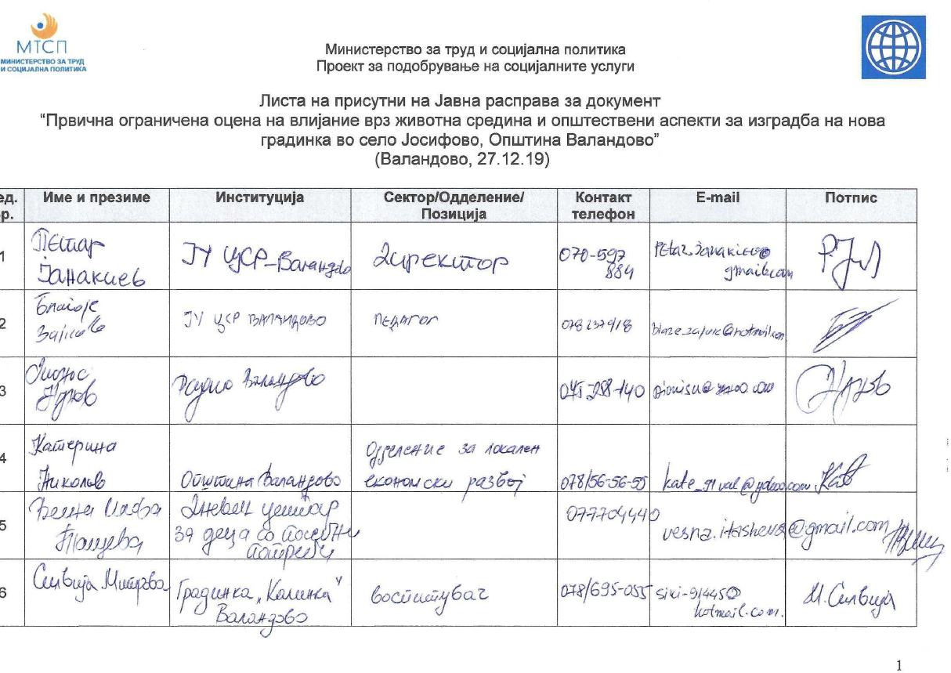
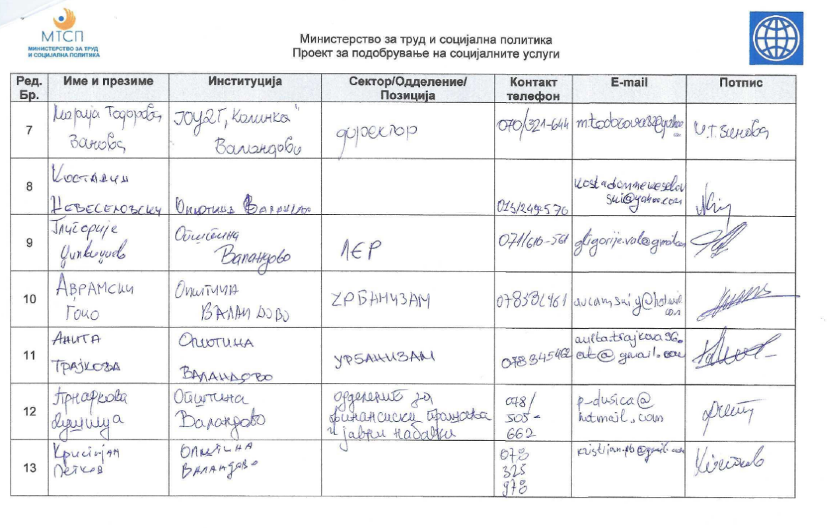

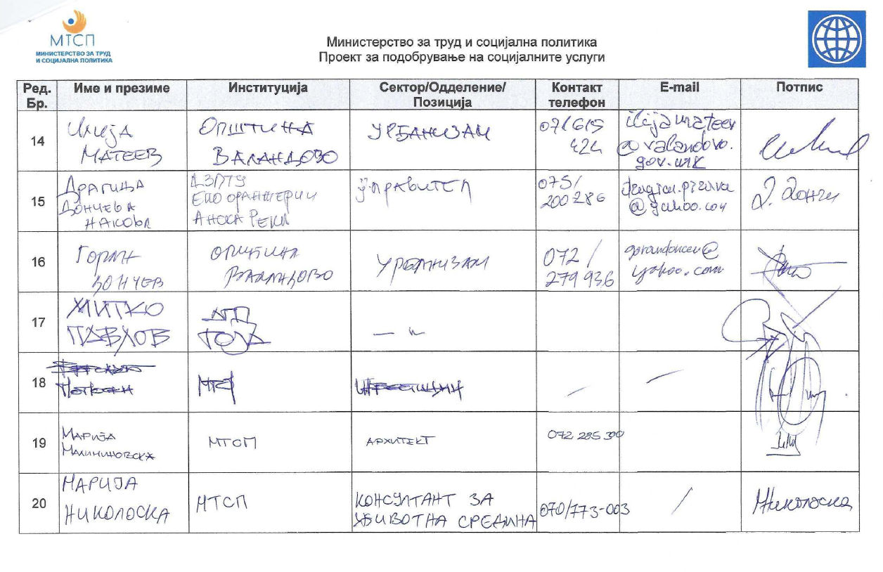

Annex 2: Photos from the public hearing event held in Municipality of Valandovo
