SOCIAL SERVICES IMPROVEMENT PROJECT

September 2020
ENVIRONMENTAL AND SOCIAL MANAGEMENT PLAN (ESMP) CHECKLIST
Extension of the existing kindergarten “Detska Radost” in Municipality of Gostivar

Prepared by:
Slavjanka Pejchinovska-Andonova, MSc, Environmental Engineer
Environmental and Social (E&S) Specialist
Content
1. Introduction 4
2. Project Description and planned activities 4
3. Environmental Category 5
4. Potential Environmental Impacts 6
5. Purpose of the Checklist ESMP 6
6. Application of the Checklist ESMP 7
7. Grievance mechanism 8
8. Monitoring and reporting 8
Annex I: Checklist ESMP for the renovation/adaptation works 9
Annex II: Site Description 23
Annex III: Map of sensitive areas in the wider and close surrounding of the project site in Municipality of Gostivar 27
Annex IV: COVID-19 considerations in construction/civil works projects 28

TABLES
Table 1 COVID-19 considerations in construction/civil works projects recommended by WB 29

FIGURES
Figure 1 Micro location of the project area in Municipality of Gostivar, city Gostivar 23
Figure 2 Current situation of the project location in Municipality of Gostivar 25
Figure 3 The look of the extended kindergarten “Detska Radost” in Municipality of Gostivar 26
Figure 4 Location of IPA “Shara Mountain” related to project location 27
Figure 5 Location of IВA “Shara Mountain” related to project location 27
Figure 6 Location of Emerald site “Shar Planina” related to project location 27
Figure 7 Location of NP “Shar Planina” (with its proposed borders – green area) related to project location 27

ANNEXES
Annex I: Checklist ESMP for the renovation/adaptation works 10
Annex II: Site Description 24
Annex III: Map of sensitive areas in the wider and close surrounding of the project site in Municipality of Gostivar 28
Annex IV: COVID-19 considerations in construction/civil works projects 29

ABBREVIATIONS
CP | Cadastral Parcel
E&S | Environmental and Social
ECEC | Early Childhood Education and Care services
ESIA | Environmental and Social Impact Assessment
ESMF | Environmental and Social Management Framework
ESMP | Environmental and Social Management Plan
ESS | Environmental and Social Standards
EU | European Union
H&S | Health and Safety
IBRD | International Bank for Reconstruction and Development
IBA | Important Bird Area
IPA | Important Plant Area
MLSP | Ministry of Labor and Social Policy
MOSHA | Macedonian Occupational Safety and Health Association
MSDS | Material Safety Data Sheets
OH&S | Occupational Health and Safety
PE | Public Enterprise
PIU | Project Implementation Unit
PPE | Personal Protective Equipment
RM | Republic of Macedonia
RNM | Republic of North Macedonia
SSIP | Social Services Implementation Project
WB | World Bank
WHO | World Health Organization

Introduction
The current conditions in the existing preschool institutions in the Republic of North Macedonia do not meet the requirements for proper childcare and are facing with lack of space for accommodation of children. For realization of a project for improving the access to Early Childhood Education and Care services (ECEC) and to social benefits and services, the Ministry of Labor and Social Policy of the Republic of North Macedonia intends to receive a loan from the International Bank for Reconstruction and Development (IBRD).
The aim of the loan is implementation of the Social Services Improvement Project (Project) which will provide renovation/adaptation of the existing kindergartens and schools, but also the construction of new ones in order to ensure more access to early childhood education.

Project Description and planned activities
The project area, where the project activities for reconstruction of the kindergarten will be performed, is located in the central part of the city Gostivar.
The extension of the kindergarten shall be with capacity to accommodate 100 children in 5 heterogeneous groups as follows:
- group from 6 months to two years 10-12 children (one group);
- group from two up to three years 12-15 children (one group);
- group from three to four years 15-18 children (one group);
- group from four to five years 18-20 children (one group);
- group from five to six years 20-25 children (one group).
The cadastral parcel where the project activities are located has an area of 3.386 m². The existing kindergarten has an area of 619,16 m² and with the reconstruction the area will increase for additional 519,52 m², which equals to a total area of 1.138,68 meters. The height of the new part will be 4,62 m.
The reconstruction of the kindergarten will be performed on the east side of the parcel.
The planned project activities will be performed in three phases:
- preparatory activities:
- Marking the boundaries of the construction site and placing a fence around the construction site with access doors and placing an information board;
- Clearance of the existing land and vegetation and transportation of the construction waste (1.450 m²) and soil waste (846 m²) to a landfill;
- Waste selection.
- reconstruction of the kindergarten:
- concrete and reinforcement works;
- isolation and hydro isolation works;
- masonry works;
- installation rain gutters, roof materials and roof insulation, new doors and windows, water supply system and sewage, heating system, electrical cables;
- landscaping - greenery arrangement of the kindergarten yard and extension of the existing pavement.
- operational phase – commissioning of the kindergarten and activities related to regular operation of the kindergarten.
The extended kindergarten will use central heating by installation of aluminum radiators and connection to the existing heating line in the primary (main) object of the kindergarten “Detska Radost”. The way of heating of the whole kindergarten will be changed from oil boilers to a high efficiency pellet boiler, by replacing the old boilers with the new pellet one. A new addition od 2 solar panels for heating of sanitary water will be added.
The kindergarten is already connected to the existing city water supply (DN110 mm) and sewage network (DN150 mm) by proper pipeline.

Environmental Category
For addressing the potential environmental and social concerns of the Project the Environmental and Social Management Framework (ESMF) was prepared (as part of the “Improving social services” of the MLSP) in May 2018, by the Environmental and Social (E&S) Specialist which is in accordance with the requirements of the World Bank. The ESMF represents a tool for Assessment and Management of Environmental and Social Standards, which allows conducting of an in-depth analysis of the environmental and social issues.
Preliminary screening according to the World Bank risk classification identifies 2 risk categories of the sub-projects: with substantial risk or with moderate risk for which different due diligence instruments need to be prepared.
“Category B+” / projects with substantial risk requires site-specific ESMPs, which should include site-specific information with mitigation measures and monitoring plan.
“Category B” /projects with moderate risk sub - projects require preparation of the ESMP Checklist by the sub-project proponent that identify potential environmental improvement opportunities and recommend measures for the prevention, minimization and mitigation of adverse environmental and social impacts.
Sub project environmental screening table for SSIP Project
Types project activities | Environmental Assessment due diligence documents required | Applicable to:
1 | Initial Limited Environmental and Social Impact Assessment (ESIA) | New construction of a kindergarten (placement of new infrastructure, expected major/moderate environmental and social impacts, usage of hazardous materials, etc.)
2 | ESMP Checklist | Renovation/adaptation of the existing kindergarten facilities/ school buildings (improving the condition of the functional characteristics of the facility: replacement of windows, demolition of walls, changing of floor, putting isolation, improving the façade, improving the way of heating/cooling, etc.)

Potential Environmental Impacts
From the implementation of the SSIP potential risks and impacts are expected to be temporary and/or reversible; low in magnitude and site-specific. These impacts are related to:
- dust nuisance and gaseous emissions,
- potential pollution of soil and water resources (accidental spillage of machine oil, lubricants, fuel, etc…),
- generation of different types of non - hazardous waste as well as small amounts of hazardous waste,
- noise and vibrations,
- possible temporary disruption of current traffic circulation,
- traffic safety,
- occupational health and safety (OHS),
- localized disturbance of soil and impacts to water.

Purpose of the Checklist ESMP
ESMP checklist will be used for the projects for renovation/adaptation of the existing kindergartens or schools’ premises. In compliance with the World Bank safeguard requirements the checklist consists of three phases:
1) General identification and scoping phase, in which the renovation/adaptation of the kindergarten works that need to be carried out. At this stage according to the carried out works the potential negative/adverse impacts can be identified. The parts 1, 2 and 3 are drafted. The second part of the ESMP Checklist contains all of the typical activities and their relation with the typical environmental issues and appropriate mitigation measures.
Considering the current situation with COVID 19, in addition to the measures for safety and protection at work, the OH&S plan shall also include measures for prevention of COVID 19. The CОVID 19 prevention measures contain recommendations from the World Bank / WHO, as well as recommendations from the Macedonian Occupational Safety and Health Association in the form of a Guide that the Contractor of the construction works needs to implement. The Contractor is required to follow/update and implement the measures that are currently in force and adopted by the Government as binding at national level. Official site for information related to COVID 19 on national level is www.koronavirus.gov.mk.

Detailed description of the measures and recommendations from the World Bank/WHO and MOSHA are presented in Annex III.
2) The second phase contains the project specifications and the bill of quantities for the renovation/adaptation works and other services related to the subproject. In this phase, the tender and the award of the works contracts and also the obligations defined in the Contract of the Contractor are defined. At the tendering stage the ESMP Checklist needs to be publicly submitted.
3) During the implementation phase the Contractor implements ESMP Checklists mitigation and monitoring, while environmental compliance (with ESMP Checklist and environmental and health and safety (H&S) regulation) and other qualitative criteria are implemented on the respective site and application checked/supervised by the site supervisor, which include the site supervisory engineer or supervisor of the project.
During the renovation/adaptation phase of the project the mitigation and monitoring measures prescribed in the ESMP Checklists are implemented by the Contractor. The compliance of the environmental and qualitative criteria are examined by the supervisor i.e. engineer. The Contractor’s environmental compliance is proven through the monitoring and mitigation plan. However, the overall responsibility for the compliance remains with the Borrower/PIU.
Practical application of the ESMP Checklist will include the achievement of Part I for having and documenting all relevant site specifics. In the second part, the activities to be carried will be checked according to the envisaged activity type and in the third part the monitoring parameters (Part 3) will be identified and applied according to activities presented in Part 2. In addition to defined parameters, the monitoring plan also includes supervision of mitigation plan implementation.
The whole ESMP Checklist filled in table for each of the type of work will be attached as integral part of bidding and work contracts and as analogue with all technical and commercial conditions which should be signed by the contracting parties.

Application of the Checklist ESMP
After completing the Environmental and Social Screening Checklist by the ESS Specialist it has been determined that, this project is classified as a “project with moderate risk”.
The ESMP Checklist is used for projects that includes only renovation/adaptation of the existing kindergartens or premises for kindergarten purposes (improving the condition of the kindergartens – removing of asbestos where needed, etc.).
The Checklist is divided in 4 parts:
- Introduction in which the project type is described, definition of the environmental category, and Checklist ESMP concept explained;
- Part 1 - Descriptive part of the project (“site passport”) location, project description, legislation and public consultation process is given;
- Part 2 - Analysis of the environmental and social aspects for every activity through yes/no questions followed by mitigation measures for each activity;
- Part 3 - Plan for monitoring of the activities during the 3 phases: preparation, renovation/adaptation and operation.
The ESMP Checklist for the renovation/adaptation works contains the environmental impacts and suitable mitigation measures in order to reduce to minimum the impacts on the environment (air, noise and water pollution). It also offers management practice for hazardous and non-hazardous wastes and measures for control of the discharged medium at the construction site. In the ESMP Checklist there are steps that need to be done if at the renovation site there are objects of cultural/archeological significance were discovered (chance-finds clause).

Grievance mechanism
Before starting with construction activities Contractor should inform the workers about the Grievance Form and the opportunity to express their compliances regarding the operation on the construction site. Local population will be introduced with this possibility by the Information posted on the Informative board within the Local Community, Municipal web site, and via local radio or local TV station.
During the implementation of the project activities if the population is unsatisfied by the project realization, they could submit their complaints trough the Grievance mechanism, by using the Form which can be found on the website of the MLSP for the SSI Project http://ssip.mtsp.gov.mk/ .
The complainant will be informed about the proposed corrective action and follow-up of corrective action within 25 calendar days upon the acknowledgement of grievance. In situation when the PIU is not able to address the particular issue verified through the grievance mechanism or if action is not required, it will provide a detailed explanation/ justification on why the issue was not addressed. The response will also contain an explanation on how the person/ organization that raised the complaint can proceed with the grievance in case the outcome is not satisfactory. At all times, complainants may seek other legal remedies in accordance with the legal framework of Republic of North Macedonia, including formal judicial appeal.

Monitoring and reporting
Monitoring of the proposed mitigation measures for environmental protection and OH&S will be performed by site supervisor or responsible person appointed by the Municipality including environmental and civil engineer that will supervise proper implementation of project activities (according the monitoring plan (part 3).
In the table part of the document clear mitigation and monitoring measures are explained in detail with the purpose to be included in the works contracts.
The mitigation measures for the project activities include, but are not limited to: the use of Personal Protective Equipment (PPE) by workers on site, air pollution prevention, amount of water used and discharged at the site, wastewater treatment, maintenance of the proper sanitary facilities for workers, waste collection of separate types (soil, metals, plastic, hazardous waste, e.g. paint residues, asbestos, motor hydraulic oil), amounts of waste, proper organization of disposal pathways and facilities, or reuse and recycling wherever possible. In addition to Part 3, the site supervisors should check whether the contractor complies with the mitigation measures in Part 2 as well as mitigation measures implementation levels.
If there are non-compliances in the implementation of ESMP Checklist measures and/or recorded in the monitoring report, penalties previously introduced in the contract will be issued. For extreme cases, a termination of the contract shall be contractually tied in.
It is very important for providing continuous performance of the project activities and successful completion of overall project trough good communication between all involved stakeholders (Contractor, Supervisor, municipal staff, PIU from MLSP and other relevant persons from the Municipality).

Annex I: Checklist ESMP for the renovation/adaptation works
PART 1: INSTITUTIONAL & ADMINISTRATIVE
Country | Republic of North Macedonia
Sub-Project title | Social safeguard Improvement Project, Republic of North Macedonia
Scope of sub-project and particular activities | Extension of the existing kindergarten “Detska Radost” in Municipality of Gostivar
Institutional arrangements  (Name and contacts) | WB (Project Team Leader) | Project Management | Local Counterpart and/or Recipient
 | To be decided  Tel:  email: | Marija Maliminovska  Responsible person for SSI Project  from MLSP  Tel: 072 285 300  email:  marija.maliminoska@mtsp.gov.mk  Maja Daskalovska  Responsible person for SSI Project  from MLSP  Tel: /  email:  MDaskalovska@mtsp.gov.mk | Aslian Snopce  Tel:071 344 083  email: a_snopce@yahoo.com
Implementation arrangements  (Name and contacts) | Safeguard Supervision | Local Counterpart Supervision | Local Inspectorate Supervision |  | Contactor
 | To be decided  Tel:  email: | To be decided  Tel:  email: | To be decided  Tel:  email: |  | To be decided  Tel:  email:
Implementation arrangements  (Name and contacts) | Supervision** (Upon completion of the procedure, the name and contact of the Supervising Engineer will be added to the fields below).
 | Will be determined after completing the public procurement procedures for the sub-project need.
SITE DESCRIPTION
Name of site | The already existing kindergarten “Detska Radost” is located on street Gave Lazareski on south and street Jaste Zdravkovski on the west site.
Describe site location (geographic description) | The project area is located in cadaster parcel CP 1920, in Municipality of Gostivar.  The residential buildings surround project location. To the north and the east, residential buildings are located, to the west the cadaster parcel borders Jaste Zdravkovski street, while Gave Lazareski street borders the parcel to the south. Approximately 100 meters to the south-west, Elementary School Goce Delcev is located, as well as Gostivar High School, located 100 meters to the east of the project location.  The General Hospital Gostivar, the City Park and Vardar River are located 1 km to the south of the project location. |  |  | Annex 1: Site information (figure from the site) [x]Y [] N
Who owns the land? | Republic of North Macedonia
Geographic description | Country: RNM  Region: Polog planning region  Municipality: Gostivar  Settlement: Gostivar
LEGISLATION
Identify national &local legislation & permits that apply to sub-project activity(s) | - Law on Environment (Official Gazette No.53/05,81/05,24/07,159/08, 83/2009, 124/2010, 51/2011, 123/12, 93/13, 163/13, 42/14, 44/15 129/15, 192/15, 39/16, 99/18);  - Law on Waters (Official Gazette No. 87/08, 6 / 09, 161/09, 83/10, 51/11, 44/12, 163/13);  - Law on Waste (Official Gazette No. 68/04, 71/04, 107/07, 102/08, 134/08, 124/10 and 51/11, 123/12, 147/13, 163/13, 146/15, 192/15);  - List of Waste Types (Official Gazette No. 100/05);  - Law on Nature Protection (Official Gazette No. 67/06, 16/06, 84/07, 59/12, 13/13, 163/13, 146/15);  - Law on Noise Protection (“ Official Gazette No. 79/07, 124/10, 47/11, 163/13, 146/15);  - Law on Chemicals (Official Gazette of the Republic of Macedonia No. 145/10, 53/11, 164/13, 116/15 and 149/15);  - Law on Ambient Air Quality (Official Gazette No. 67/04 with amendments Nos. 92/07, 35/10, 47/11, 59/12, 163/13, 10/15, 146/15);  - Law on Protection of Cultural Heritage (Official Gazette No. 20/04, 115/07, 18/11, 148/11, 23/13, 137/13, 164/13, 38/14, 44/14);  - Law on Occupational Health and Safety (Official Gazette No. 92/07, 98/10, 93/11, 136/11, 60/12, 23/13, 25/13, 164/13);  - Law for Health Protection (Official Gazette No. 07/07, 44/11, 145/12, 87/13);  - Law on Access to Public Information (Official Gazette of RM no. 13/06, 86/08, 06/10, 42/14, 148/15, 55/16);  - Law on Traffic Safety (Official Gazette of RM no. 169/15, 55/16);  - Law on the Protection of Children (Official Gazette of the RM ”No. 23/13, 12/14, 44/14, 144/14, 10/15, 25/15, 150/15, 192/15, 27/16, 163/17, 21/18 and 198 /18);  - Rulebook on standards and norms for performing activities of child care institutions (Official Gazette of the RM No. 28/14, 40/14, 136/14, 71/15 and 170/16).
PUBLIC CONSULTATION
Identify when / where the public consultation process took place and what were the remarks from the consulted stakeholders | The draft Environmental and Social Management Plan (ESMP) Checklist (for the projects with moderate risk) will be available for the public for 14 days on web site of the Municipality of Gostivar and the web site of the MLSP PIU. All relevant comments and suggestions received by the stakeholders will be included into the final ESMP checklist and will be submitted to the PIU for the approval by the MLSP Environmental Expert and World Bank Specialist. Approved Final version of ESMP Checklist should be included in the Grant Agreement with the proponent and respective bidding documents and construction contracts.
INSTITUTIONAL CAPACITY BUILDING
Will there be any capacity building? | [x] N or []Y

PART 2: ENVIRONMENTAL /SOCIAL SCREENING
Will the site activity include/involve any of the following potential issues/risks: | Activity | Status | Additional references
 | A. General conditions |  | See Section A
 | B. General renovation/adaptation activities  - Site specific vehicular traffic  - Increase in dust and noise from renovation/adaptation activities  - Generation of waste  - Transport of materials and waste | [x] Yes [ ] No | If “Yes” , See Section A, B below
 | C. Are the renovation/adaptation activities taking place near water bodies such as rivers, lakes, etc.?  - Increase in sediments loads in water bodies  - Changes of water flow  - Pollution of water due to temporary waste disposal or spill leakages | [] Yes [x ] No | If “Yes”, See Section A, B, C below
 | D. Vicinity of any historical building/s or areas  - Risk of damage to known/unknown historical buildings/areas | [ ] Yes [x] No | If “Yes”, See Section A, B, D below
 | E. Traffic and Pedestrian Safety  - Site specific vehicular traffic  - Site is in a populated area | [x] Yes [ ] No | If “Yes”, See Section A, B, E below
 | F. Usage of hazardous or toxic materials and generation of hazardous waste  - Removal and disposal of toxic and/or hazardous waste during the renovation activities  - Storage of machine oils and lubricants | [x] Yes [ ] No | If “Yes”, See Section A, B, F below
 | G. Generation of asbestos waste during the demolition of existing kindergarten parts (roof, walls, floor) | [ ] Yes [x] No | If “Yes”, See Section A, B, G below
 | H. Replacement/Removal of mercury lights | [ ] Yes [x] No | If “Yes”, See Section A, B, H below
 | I. Dismantling of underground installations | [] Yes [x ] No | If “Yes”, See Section A, B, I below

ACTIVITY | PARAMETER | MITIGATION MEASURES CHECKLIST
A. General Conditions | Community safety and OH&S for workers | Community OH&S measures:  - The public in the Municipality should be notified of the works through appropriate notification in the media and/or at publicly accessible sites (including the site of the works, municipal information table and municipal website http://gostivari.gov.mk/mk/pocetna/);  - The local construction and environment inspectorates and communities in the Municipality should be notified for the project activities renovation/adaptation of the existing kindergarten;  - All legally required permits have been acquired for the project activities;  - Preparation of the Traffic Management Plan (it is necessary because the site in Gostivar is frequently an area with heavy traffic, densely populated area and area with the educational and health institutions);  - Preparation and implementation of the Site Management Plan;  - Appropriate installation of signposting of the project site will inform workers of key rules and regulations to follow;  - Ensure appropriate marking out and out of the reconstruction site;  - Placed warning tapes signalizing forbidden entrance of unemployed persons especially children’s.  - All work will be carried out in a safe and disciplined manner designed to minimize impacts on workers, citizens at the project location and environment;  - Separation of the work areas from extension activities and occupied areas of the kindergarten as much as possible using physical barriers;  - Ensuring the safe movement and access (through separate paths) of parents, stuffs and children that will use the existing building of the kindergarten which will be upgraded;  - The surrounding area (kindergarten yard) should be kept clean, without waste disposed there. The waste need to be collected and immediately removed from the yard as it could be a cause of injury;  - Strictly prohibition for storage of hazardous waste on the location where the upgrading activities will be performed;  - Signing a Contract between the Contractor and the licensed company for hazardous waste before the commencement of construction activities and collection of the waste on call;  - Regular maintenance of vehicles to minimize potentially serious accidents caused by equipment malfunction or premature failure, spills and increased emissions;  - The work during the breaks between kindergarten activities and children's activities in the kindergarten yard should be prohibited;  - If possible, the construction activities to be implemented with reduced intensity while the children are present in the kindergarten in order to prevent children from being exposed to increased noise levels  - If possible begin and end of upgrading activities during the summer months or while staff and kids are not in kindergarten or their number is significantly reduced;  - Regular maintenance and cleaning of the site in order to minimize dust emissions.  OH&S measures for workers:  - Community and Worker’s OH&S measures should be applied (first aid, protective clothes for the workers, appropriate machines and tools);  - Workers who will be engaged, will comply with international good practice (will always wear hats, masks and safety glasses, harnesses and safety boots);  - Equipment should be handled only by experienced and trained personnel, thus reducing the risk of accidents;  Firefighting measures:  - Procedures in the case of fire are conveyed to all employees.  - The part of the project location that is not under rehabilitation will be kept clean  - Constant presence of attested firefighting devices should be ensured on site in case of fire damage. Their position is marked and communicated to the workers. The level of fire-fighting equipment must be assessed and evaluated through a typical risk assessment.  - Supervision of fire protection/fire-fighting facilities to be carried out by a designated staff.  Covid measures:  - Implementation of the proposed measures for protection from COVID 19 adopted by the Government of the Republic of North Macedonia at the proposal of the Commission for Infectious Diseases and the Ministry of Health;  - Stay up to date with the newest instructions/recommendations provided by the official authorities  - Nomination of one person from the Contractor that will responsible for following the measures adopted by the Government and will apply them in the operation of the construction site at the project location.  - To ensure implementation of all necessary requirements by providing the necessary protection personal equipment for all workers on site according the proposed measures: keeping records on COVID 19 cases, support workers who are in quarantine and regular informing the official institutions if any case occur.  - Implementation of measures for COVID - 19 for different aspects are given in Table 1 that are related with OH&S during COVID – 19 pandemics.
 | Accidents prevention | - Construction machinery and equipment should be in proper working condition;  - At the project location there should be Spill prevention kit which will prevent further extension of the spillage;  - Firefighting distinguishers should be in proper condition;  - Work site should be protected by a warning type.
B. General Renovation/adaptation activities | Air Emission and Air Quality | - Ensure all vehicles and machinery use petrol from official sources (licensed gas stations) and on fuel determined by the machinery and vehicles producer;  - Ensure all transportation vehicles and machinery is regularly maintained and attested;  - All machinery needs to be equipped with appropriate emission control equipment;  - When transporting waste/materials the vehicles must be covered in order to decrease the dust emission;  - To minimize dust the construction materials should be stored in appropriate places and be covered;  - Washing of road transport vehicles and wheels will be conducted regularly, in previously identified sites equipped with, minimally, oil and grease collector;  - Clearing activities must be done during agreed working times and permitting weather conditions to avoid drifting of dust into neighboring area.
 | Noise disturbance | - The level of noise should be not exceed more that national limited level (according to national legislation and EU requirement);  - The renovation/adaptation work should be not permitted during the nights, the operations on site shall be restricted to the hours 7.00 -19.00;  - Noise suppression measures must be applied to all construction equipment. During operations the engine covers of generators, air compressors and other powered mechanical equipment should be closed. Should the vehicles or equipment not be in good working order, the constructor may be instructed to remove the offending vehicle or machinery from the site;  - Mechanical equipment is effectively maintained.
 | Waste management | - Containers for each identified waste category are provided in sufficient quantities and positioned for separate collection;  - Communal service enterprise for waste collection (PE “Komunalec”) is the responsible for communal and inert waste collection and transportation within the Municipality of Gostivar and City of Gostivar. The waste disposal will be performed in the Rusino landfill. For the expected waste types from cleaning and renovation/adaptation activities the waste collection and disposal pathways and sites will be identified;  - The different waste types that could be generated at the construction site need to be identified and classified according to the List of Waste (Official Gazette no.100/05);  - The main waste would be classified under the Waste Chapter 17 “Construction and demolition wastes (including excavated soil from contaminated sites)” with the waste code 17 05 04 – Excavated soil, 17 09 04 – Mixed waste from construction site, 17 01 – Waste from concrete, asphalt, 18 01 03* - wastes whose collection and disposal is subject to special requirements in order to prevent infection;  - Small amount of solid municipal waste can be found (beverages, food), as well as packaging waste (bottles, paper, glass, etc.);  - The construction waste will be separated from the general waste, liquid and chemical waste on site, by sorting in appropriate containers;  - The records of waste disposal will be regularly updated and archived;  - Only licensed collectors of waste will collect and dispose of the construction waste;  - All of the records of the disposed waste will be kept as proof for proper management;  - Construction waste from site needs to be instantly removed and reused if possible;  - For the possible hazardous waste (motor oils, vehicle fuels) an authorized collector needs to be appointed to collect and dispose of it properly;  - A portion of the generated waste is assumed to be infectious medical waste which originates from the implementation of the preventive measures for COVID 19 such as masks and gloves;  - The materials should be covered during the transportation to avoid waste dispersion;  - Burning of construction waste should be prohibited.
 | Water and soil | - In the event when hazardous spillage occurs, it needs to be stopped and removed, then the site needs to be cleaned and the procedures and measures for hazardous waste management need to be followed;  - The waste generated from the application of the measures of COVID 19 need to be collected and stored appropriately in separate leak proof containers. After the storage the waste will be disposed by a licensed company.  - In the case of any run-off coming from the works, in order to avoid contamination of the area it needs to be collected on site and placed in a temporary retention basin;  - The temporary or final disposal of any waste stream near the water courses is forbidden;  - Servicing of vehicles and machinery is forbidden to be conducted on the construction-site;  - Prevent as much as possible, oil and other pollutants leakages to water and soil.
 | Nature protection | - Collection of the generated waste on daily basis, selection of waste, transportation and final disposal on appropriate places;  - After finishing with renovation/adaptation activities, the location should be return to the pre work condition and if not possible than it will be adequately managed;  - Several protected areas are located in the wider surrounding of the project site: 1) Important Plant Area (IPA) “Shara Mountain” (located about 5 km west from the project site); 2) Important Bird Area (IВA) “Shara Mountain” (located about 5.4 km west from the project site); and 3) Emerald site “Shar Planina” (located about 5 km west from the project site). In Annex 1 are presented locations of the protected areas, regards the project location. Because of the wide distance between them and project area, the project implementation will not cause any adverse impact on the flora and fauna.  - Because of the wide distance between protected areas (mentioned in Annex I) and the project site, the implementation of the project activities shall not cause any adverse impact on the existing flora and fauna because it is located in an urban part of the City of Gostivar.
 | Transport and Materials Management | - The routes for the machines are clearly defined;  - Access of the construction and material delivery vehicles are strictly controlled, especially during the wet weather;  - Ensure all transportation vehicles and machinery have been equipped with appropriate emission control equipment, regularly maintained and attested  - Distribution of materials for the kindergarten need to be announced and coordinated with the Municipality of Gostivar. The Contractor will take safety measures to prevent accidents;  - All materials prone to dusting are transported in closed or covered trucks;  - All materials prone to dusting and susceptible to weather conditions are protected from atmospheric impacts either by windshields, covers, watered or other appropriate means;  - Project area is regularly swept and cleaned. Spilled materials are immediately removed from a project area and cleaned. Access roads are well maintained.
E. Traffic and Pedestrian Safety | Direct or indirect hazards  to public traffic and  children and parents and kindergarten staff by renovation/adaptation  activities | The construction site including the regulation of the traffic will be accordingly secured by the Contractor. This includes but is not limited to:  - The citizens from the neighboring buildings (located near the project site and children and parents and kindergarten staff), as well as official stuff from the High School “Gostivar” and Elementary School “Goce Delcev ” need to be timely informed of the upcoming works;  - In an event where the traffic around the project area will be interrupted the Contractor in cooperation with the Municipality of Gostivar need to organize alternative routes;  - Placing of sign posts, warning signs, barriers (vertical signalization and signs at the construction site): the citizens (children and parents and kindergarten staff) will be warned about the potential hazards;  - Adequate warning tapes and signage need to be provided and placed;  - Forbidden of entrance of unemployed persons within the fence;  - Set up a special traffic regime for the vehicles of the contractor during the period of renovation/adaptation (together with the municipal staff and police department) and installation of signs to ensure safety, traffic flow and access to land and facilities;  - Ensure pedestrian safety. Special focus for safety of children and parents and kindergarten staff at the kindergarten if the project activities take place during the presence of the children in the kindergarten premises (fence off the site, install safe corridors, etc.);
F. Usage of hazardous or toxic materials and generation of hazardous waste | Toxic / hazardous materials management  and  Hazardous waste  management | - Temporarily storage on site of all hazardous or toxic substances (including wastes) will be in safe containers labeled with details of composition, properties and handling information. Chemicals are managed, used and disposed, and precautionary measures taken as required in the Material Safety Data Sheets (MSDS);  - According work instructions on using hazardous materials shall be provided to workers.  - The containers with hazardous substances must be kept closed, except when adding or removing materials/waste. They must not be handled, opened, or stored in a manner that may cause them to leak;  - The containers holding ignitable or reactive wastes must be located at least 15 meters from the facility’s property line. Large amounts of fuel will not be kept at the site;  - The containers of hazardous substances shall be placed in a leak-proof container to prevent spillage and leaking. This container will possess secondary containment system such as bunds (e.g. banded-container), double walls, or similar. Secondary containment system must be free of cracks, able to contain the spill, and be emptied quickly;  - Hazardous waste should not be mixed and will be transported and handled only by licensed companies in line with the national regulation;  - Possible hazardous waste (motor oils, vehicle fuels, lubricants) should be collected separately and authorized company should be sub-contracted to transport and finally dispose the hazardous waste;  - Hazardous waste will be disposed only to licensed landfills or processed in licensed processing Plants;  - Paints with toxic ingredients or solvents or lead-based paints will not be used.  - The waste generated from the application of the measures of COVID 19 it will be considered as hazardous and as such will be stored appropriately in separate leak proof containers. After the storage the waste will be disposed by a licensed company.

PART 3: MONITORING PLAN
What  parameter is to be monitored? | Where  is the parameter to be monitored? | How  is the parameter to be monitored (what should be measured and how)? | When  is the parameter to be monitored (timing and frequency)? | By Whom  is the parameter to be monitored– (responsibility)? | How much  is the cost associated with implementation of monitoring | Why (is the parameter being monitored)?
Preparatory phase
Community safety and OH&S for workers | On the site | By checking if there is a Board with information about the Investor, Contractor and Supervisor, fencing and marking the location, To prevent health and safety risks – mechanical injures  and to provide safe access and mobility of all which will be affected near the project location in Municipality of Gostivar | Before works commencement | Supervisor  Representative from the Municipality of Gostivar | Included in the project budget | In order to be assured that at the project location measures for the safety of the community and the OH&S for workers will be implemented by the contractor
Obtained all required  permits | At the city  Administration in Gostivar | Inspection of all  required documents | Before works start | Supervisor  Representative from the Municipality of Gostivar | Included in the project budget | In order to check if the Contractor has legally obtained all required permits
Accidents prevention | On the site | By checking if there are spill kits, firefighting appliances, the vehicles and equipment is in working condition at the project location in Municipality of Gostivar | Before works commencement | Supervisor  Representative from the Municipality of Gostivar | Included in the project budget | In order to be assured that at the project location measures for accidents prevention will be implemented and the accidents will be minimized
Renovation/adaptation phase
Air emission and Air quality | At and around the  site | Air pollution parameters of dust, particulate matter | Upon complaint or negative  inspection finding | Supervisor | Contractor budget | In order to be assured that at the project location measures for air emission and air quality will be implemented by the Contractor and there will be no complaints by the local citizens
Noise disturbance | On site | Measuring levels of noise should be carried out in the case of complaints and negative findings of the inspection. | Regularly | Contractor;  Accredited company  for measuring the  level of provided by the contractor;  Authorized environmental inspector, Construction inspector, MLSP PIU | Part of the regular Contractor cost | In order to be assured that at the project location measures for noise disturbance will be implemented by the Contractor and there will be no complaints by the local citizens
Waste management | On the site | Review the documentation – identification of the waste type according the List of waste,  - Visual inspection that the waste is collected separately in adequately labeled containers, leakages.  - review of the waste Contracts and licenses of companies contracted for the collection and disposal of waste | At the beginning of works, than periodically | Contractor – Bidder  Supervisor  Municipality of Gostivar | Included in the project budget | In order to be assured that at the project location measures for waste management will be implemented by the Contractor and there will be no complaints by the local citizens
Water and soil | At the site of the renovation/adaptation and where the  machines and vehicles are  operating | Visual checks | During the works, daily | Contractor;  Supervisor of the  construction works;  Authorized  environmental  inspector, Construction  inspector, MLSP PIU | Included in the project budget | In order to be assured that at the project location measures for water and soil will be implemented by the Contractor and the quality of the water recipient will remain the same
Nature protection | On the site and around the renovation/adaptation site | Visual checks | Periodically | Contractor – Bidder  Supervisor  Municipality of Gostivar | Included in the project budget | In order to be assured that at the project location measures for nature protection will be implemented by the Contractor
Transport and Materials Management | On site | Visual checks on how the materials are disposed of and whether they are properly transported | Regularly | Supervisor | Part of the regular Contractor cost | In order to be assured that at the project location measures for transport and materials management will be implemented by the Contractor
Direct or indirect hazards  to public traffic and  children and parents and kindergarten staff by renovation/adaptation  activities | On the site | Check the documentation:  - Whether all competent authorities have been notified,  - Whether all the necessary permits and approvals have been obtained,  Visual check of the transport of materials, children, parents and kindergarten staff corridors and crossings, traffic regulation, etc. | Continuously | Contractor – Bidder | Included in the project budget | In order to be assured that at the project location measures for occupational safety of the children, parents and the public traffic will be implemented by the Contractor
Toxic / hazardous materials management  and  Hazardous waste  management | On site visual assessment | Proper handling and storage is checked according to Material Safety Data Sheets (MSDS)  -Visual inspection and review of documents in terms of:  - Adequate collection and storage of hazardous and toxic substances (including fuel) and waste  - Transportation of hazardous waste only by authorized companies,  - Review of declarations of purchased paint and solvents (avoidance of hazardous paint and solvents) | Continuously, when the remains are removed | Supervising engineer,  Inspection  Contractor – Bidder  Supervisor | Part of the regular Contractor cost  Included in the project budget | In order to be assured that at the project location measures for hazardous waste  management will be implemented by the Contractor
Operational Phase
Plan for regular maintenance of the installations (water supply, sewage network, electricity, heating) within the kindergarten | / | Overview of the Plan for regular and preventive maintenance | Before the start of the operation of the kindergarten | Representatives from the Municipality of Gostivar  Communal inspector  Responsible persons employed in the kindergarten | Municipality budget | In order to be assured that at the project location measures for maintenance of the installations within the kindergarten will be implemented by the responsible person from the Kindergarten
Fire Protection Plan | Before the start of the reconstructed kindergarten operation  To ensure that all fire protection measures are implemented | Review of the Plan | At the beginning of the reconstructed kindergarten operation. | Responsible persons employed in the kindergarten | Municipality budget | In order to be assured that at the project location measures from the fire protection plan will be implemented by the responsible person from the Kindergarten
Waste management plan | / | Overview of the waste management plan and including of the extended part of the kindergarten | Before the start of the operation of the extension part of the kindergarten | Representatives from the Municipality of Gostivar  Communal inspector  Responsible persons employed in the kindergarten | Municipality budget | In order to be assured that at the project location measures in the waste management plan will be implemented by the responsible person from the Kindergarten

Annex II: Site Description
Municipality of Gostivar is a municipality located in the western part of North Macedonia. The municipality borders Brvenica and Vrapciste Municipalities to the north, Republic of Albania and Republic of Kosovo to the west, Mavrovo and Rostusa, Kicevo Municipality to the south and Brvenica and Vrapciste Municipalities to the east.
Gostivar is also the name of the city where the kindergarten is located and the municipal seat is found. The municipality has a population of 81042 inhabitants.
The reconstruction of the existing kindergarten “Detska Radost” will take place on CP 1920 on an area of 520 m².
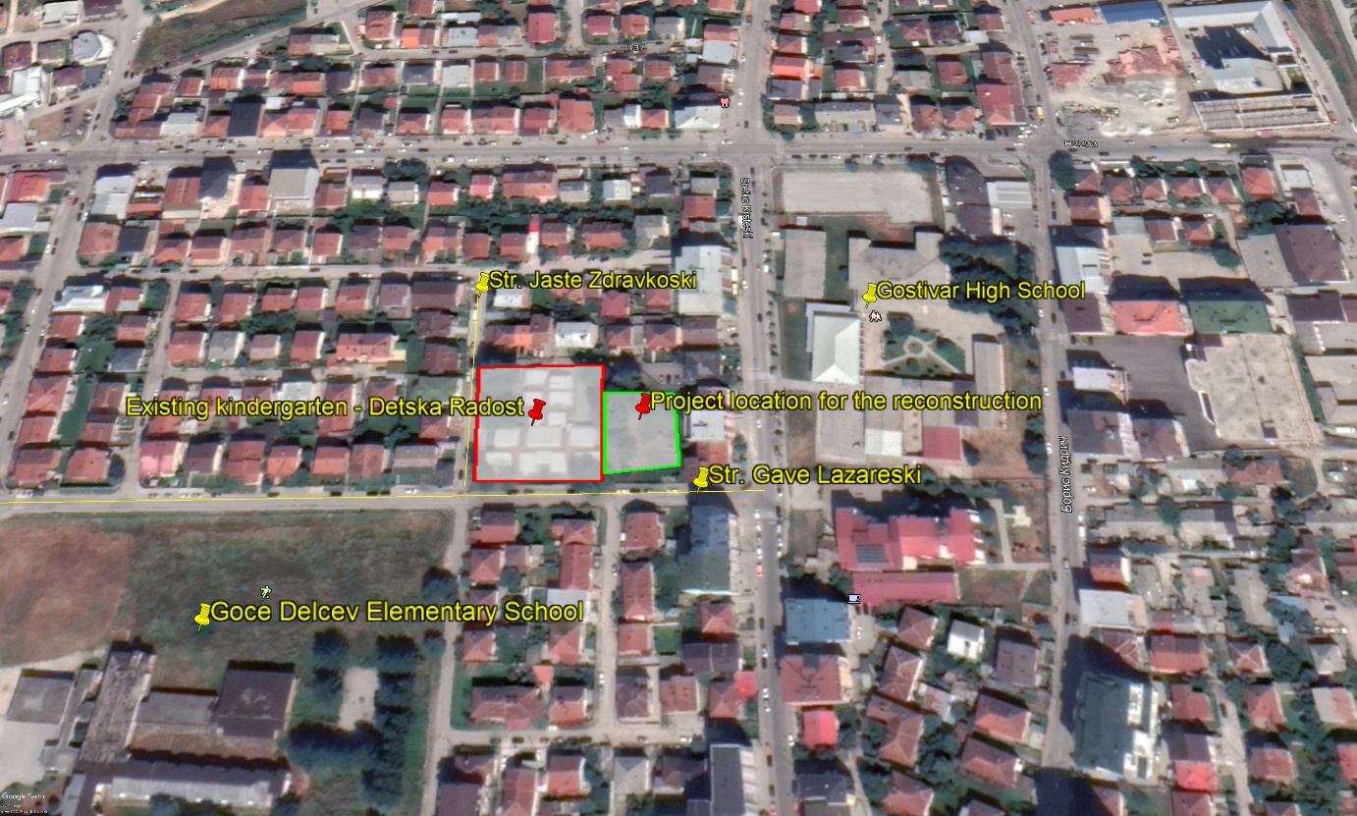
Figure 1 Micro location of the project area in Municipality of Gostivar, city Gostivar
The description of the project location is presented in Annex I. On the Figure 2 are presented photos that shows current situation of the existing kindergarten.
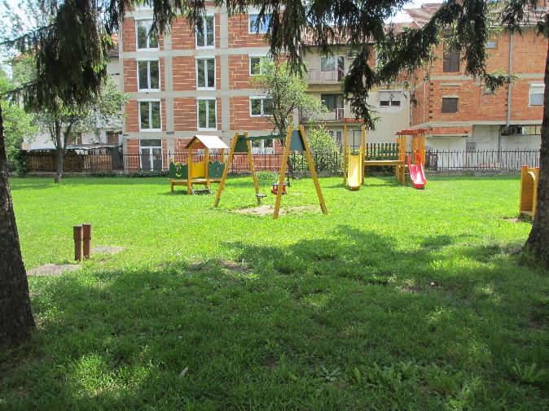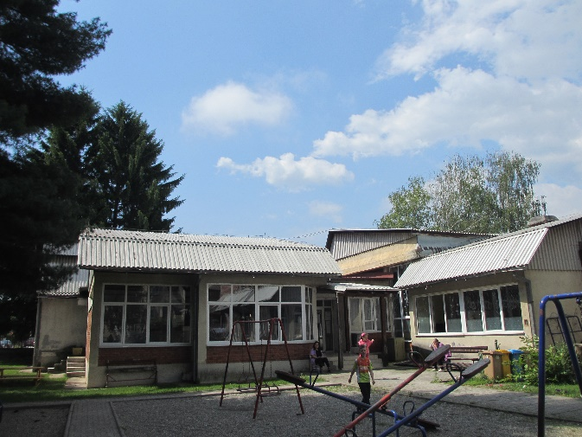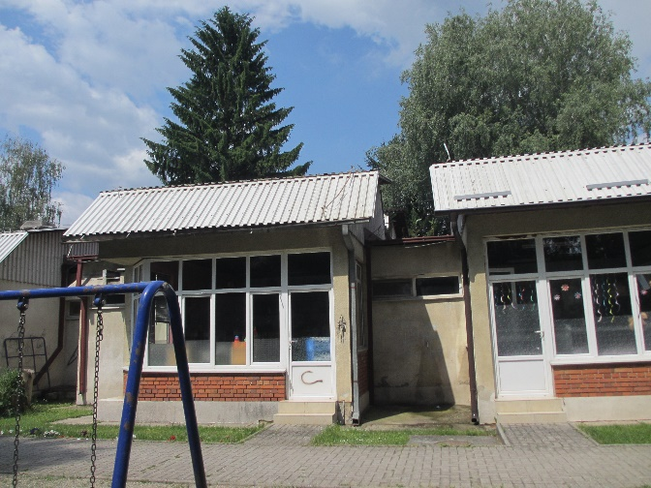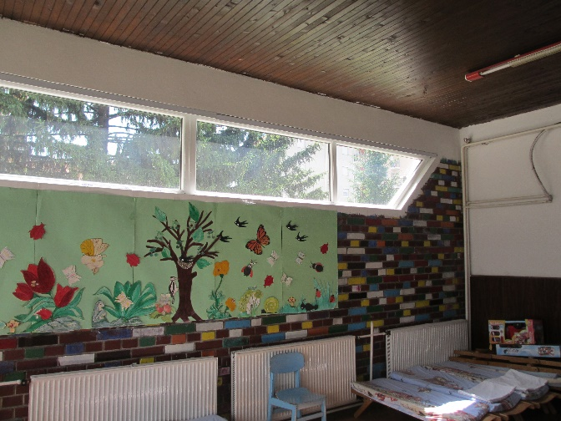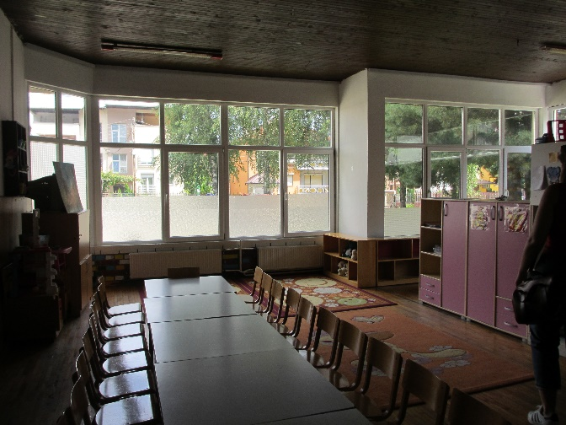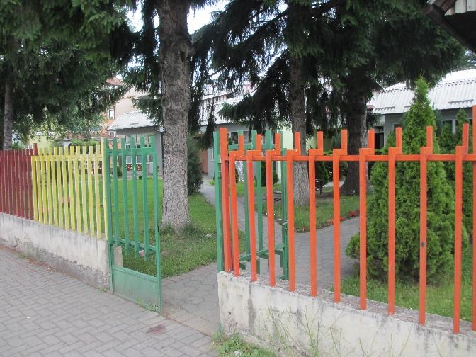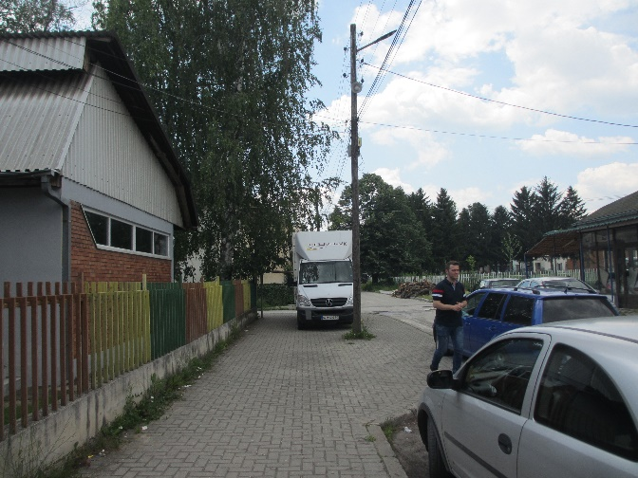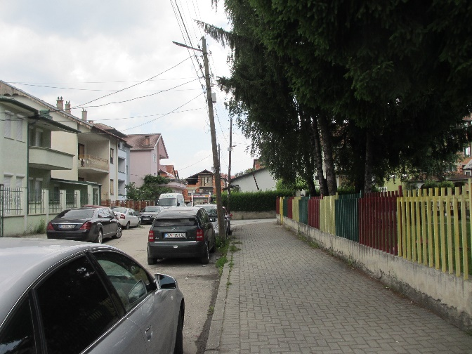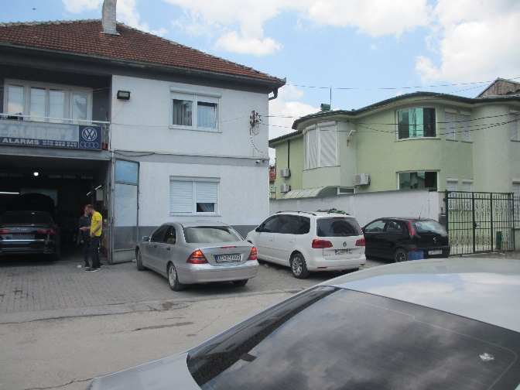
Figure 2 Current situation of the project location in Municipality of Gostivar

Figure 3 The look of the extended kindergarten “Detska Radost” in Municipality of Gostivar

Annex III: Map of sensitive areas in the wider and close surrounding of the project site in Municipality of Gostivar
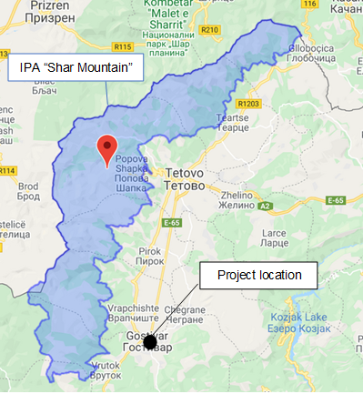 | 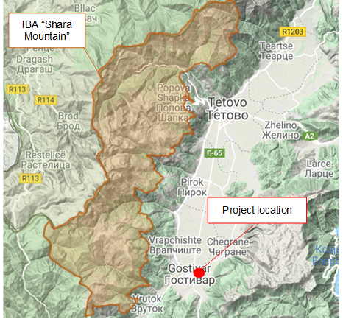
Figure 4 Location of IPA “Shara Mountain” related to project location | Figure 5 Location of IВA “Shara Mountain” related to project location
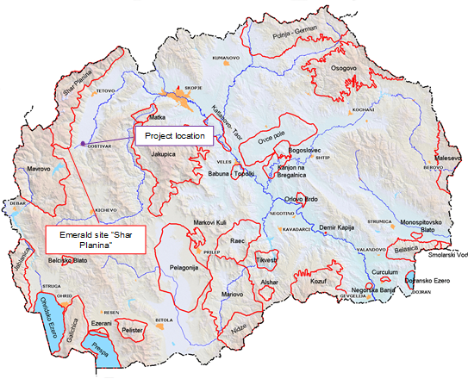 | 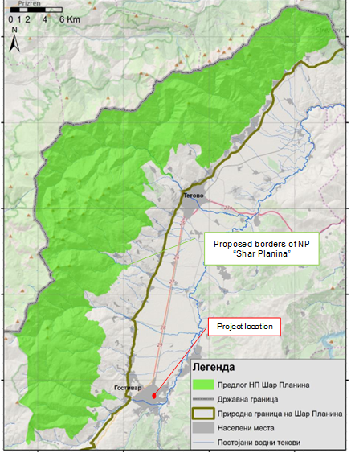
Figure 6 Location of Emerald site “Shar Planina” related to project location | Figure 7 Location of NP “Shar Planina” (with its proposed borders – green area) related to project location

Annex IV: COVID-19 considerations in construction/civil works projects
Taking into account the new situation with the appearance of the virus COVID 19, besides the standard measures for safety and protection at work it is necessary to implement measures for protection from COVID 19.
Undoubtedly, the Contractors will face many challenges in the new situation, such as:
- Inability to purchase protective equipment and disinfectants due to lack on the market,
- Lack of labor due to limited movement and absences from work,
- Inability to provide materials and work equipment due to congestion in all segments of life in the country,
- Employees' concerns about their livelihoods due to reduced workload, etc.
First, it is necessary to implement the measures for protection from COVID 19 adopted by the Government of the Republic of Northern Macedonia at the proposal of the Commission for Infectious Diseases and the Ministry of Health. These measures should be constantly updated in accordance with the latest provisions introduced by the Government. The Contractor is required to nominate a responsible person who will follow the measures adopted by the Government and will apply them in the operation of the construction site at the project location.
Links of the national institutions responsible for COVID 19 where the Contractor could find updated information and recommendations:
- Government of the Republic of North Macedonia - https://vlada.mk/node/20488?ln=en-gb
- Ministry of Health - http://zdravstvo.gov.mk/korona-virus/
- Ministry of Labour and Social Policy - http://mtsp.gov.mk/covid-19.nspx
- Ministry of transport and communications - http://mtc.gov.mk/Preporaki%20od%20Vlada
- Official site for COVID – 19 - https://koronavirus.gov.mk/en
On national level in addition to the measures introduced by the Government for protection from COVID 19, the Macedonian Occupational Safety and Health Association developed a Guide to Safety and Health at Work in Construction Prevention from the Corona virus. The Guide contains measures that the Contractor is required to implement in order to eliminate the possible ways of obtaining and transmitting COVID 19 among the workers on construction site.
In more detail in several chapters, the Guide contains:
- Challenges in construction;
- Obligations for the Contractor;
- Obligations for workers;
- Liabilities for Investors;
- Ways of proceeding in cases of suspected case or cases infected with COVID 19;
- Contact phones of national institutions responsible for contacting the occurrence of the event infected with COVID 19.
The text of the Guide to Safety and Health at Work in Construction Prevention from the Corona virus on the Macedonian language is given on the following link
http://mzzpr.org.mk/wp-content/uploads/2020/04/covid19-%D0%B3%D1%80%D0%B0%D0%B4%D0%B5%D0%B6%D0%BD%D0%B8%D1%88%D1%82%D0%B2%D0%BE.pdf.
The Contractor also needs to implement the requirements introduced by the World Bank related to the protection of COVID 19.
Regarding the COVID-19 considerations in construction/civil works projects given by the World Bank, they are divided in several segments/issues and in details are shown on Table 1.
Table 1 COVID-19 considerations in construction/civil works projects recommended by WB
COVID-19 considerations in construction/civil works projects
Covid-19 issues | Type of activities
The Contractor should identify measures to address the COVID-19 situation taking into account the location, existing project resources, availability of supplies, capacity of local emergency/health services, the extent to which the virus already exist in the area.
PIU and Contractor should establish specific procedures for addressing COVID 19 issues on the construction site. Procedures should be implemented, documented and updated in accordance with the latest changes introduced by the Government and the conditions on the construction site.
Assessing workforce characteristics | • The Contractor should prepare a detailed profile of the project work force, key work activities, schedule for carrying out such activities, different durations of contract and rotations;  • This should include a breakdown of workers who reside at home (i.e. workers from the community), workers who lodge within the local community and workers in on-site accommodation (i.e. workers camp). Where possible, it should also identify workers that may be more at risk from COVID-19, those with underlying health issues or who may be otherwise at risk;  • Consideration should be given to ways in which to minimize movement in and out of site. This could include lengthening the term of existing contracts, to avoid workers returning home to affected areas, or returning to site from affected areas.
Entry/exit to the work site and checks on commencement of work | • Establishing a system for controlling entry/exit to the site, securing the boundaries of the site, and establishing designating entry/exit points (if they do not already exist). Entry/exit to the site should be documented;  • Training security staff on the (enhanced) system that has been put in place for securing the site and controlling entry and exit, the behaviors required of them in enforcing such system and any COVID -19 specific considerations;  • Training staff who will be monitoring entry to the site, providing them with the resources they need to document entry of workers, conducting temperature checks and recording details of any worker that is denied entry;  • Confirming that workers are fit for work before they enter the site or start work. While procedures should already be in place for this, special attention should be paid to workers with underlying health issues or who may be otherwise at risk. Consideration should be given to demobilization of staff with underlying health issues;  • Checking and recording temperatures of workers and other people entering the site or requiring self-reporting prior to or on entering the site;  • Providing daily briefings to workers prior to commencing work, focusing on COVID-19 specific considerations including cough etiquette, hand hygiene and distancing measures, using demonstrations and participatory methods;  • During the daily briefings, reminding workers to self-monitor for possible symptoms (fever, cough, and other respiratory symptoms) and to report to their supervisor or the COVID-19 focal point if they have symptoms or are feeling unwell;  • Preventing a worker from an affected area or who has been in contact with an infected person from returning to the site for 14 days or (if that is not possible) isolating such worker for 14 days;  • Preventing a sick worker from entering the site, referring them to local health facilities if necessary or requiring them to isolate at home for 14 days.
General hygiene | • Placing posters and signs around the site, with images and text in local languages (MK/ALB);  • Ensuring handwashing facilities supplied with soap, disposable paper towels and closed waste bins exist at key places throughout site, including at entrances/exits to work areas; where there is a toilet, canteen or food distribution, or provision of drinking water; in worker accommodation; at waste stations; at stores; and in common spaces. Where handwashing facilities do not exist or are not adequate, arrangements should be made to set them up. Alcohol based sanitizer (if available, 60-95% alcohol) can also be used;  - Training workers and staff on site on the signs and symptoms of COVID-19, how it is spread, how to protect themselves (including regular handwashing and social distancing) and what to do if they or other people have symptoms;  • Setting aside part of worker accommodation for precautionary self-quarantine as well as more formal isolation of staff who may be infected.
Cleaning and waste disposal | • Providing cleaning staff with adequate cleaning equipment, materials and disinfectant;  • Training cleaning staff on appropriate cleaning procedures and appropriate frequency in high use or high-risk areas;  • Where it is anticipated that cleaners will be required to clean areas that have been or are suspected to have been contaminated with COVID-19, providing them with appropriate PPE: gowns or aprons, gloves, eye protection (masks, goggles or face screens) and boots or closed work shoes. If appropriate PPE is not available, cleaners should be provided with best available alternatives;  • Training cleaners in proper hygiene (including handwashing) prior to, during and after conducting cleaning activities; how to safely use PPE (where required); in waste control (including for used PPE and cleaning materials);  • Any medical waste produced during the care of ill workers should be collected safely in designated containers or bags and treated and disposed of following relevant requirements (e.g., national - http://www.moepp.gov.mk/?nastani=%d0%bf%d1%80%d0%b5%d0%bf%d0%be%d1%80%d0%b0%d0%ba%d0%b8-%d0%b7%d0%b0-%d1%83%d0%bf%d1%80%d0%b0%d0%b2%d1%83%d0%b2%d0%b0%d1%9a%d0%b5-%d1%81%d0%be-%d0%be%d1%82%d0%bf%d0%b0%d0%b4-%d0%b7%d0%b0-%d0%b3%d1%80,  WHO). If open burning and incineration of medical wastes is necessary, this should be for as limited a duration as possible. Waste should be reduced and segregated, so that only the smallest amount of waste is incinerated.
Adjusting work practices | • Decreasing the size of work teams;  • Limiting the number of workers on site at any one time;  • Changing to a 24-hour work rotation;  • Adapting or redesigning work processes for specific work activities and tasks to enable social distancing, and training workers on these processes;  • Continuing with the usual safety trainings, adding COVID-19 specific considerations. Training should include proper use of normal PPE. While as of the date of this note, general advice is that construction workers do not require COVID-19 specific PPE, this should be kept under review;  • Arranging (where possible) for work breaks to be taken in outdoor areas within the site;  • Consider changing canteen layouts and phasing meal times to allow for social distancing and phasing access to and/or temporarily restricting access to leisure facilities that may exist on site, including gyms;  • At some point, it may be necessary to review the overall project schedule, to assess the extent to which it needs to be adjusted (or work stopped completely) to reflect prudent work practices, potential exposure of both workers and the community and availability of supplies, taking into account Government advice and instructions.
Project medical services | • Expanding medical infrastructure and preparing areas where patients can be isolated. Isolation facilities should be located away from worker accommodation and ongoing work activities. Where possible, workers should be provided with a single well-ventilated room (open windows and door). Where this is not possible, isolation facilities should allow at least 1 meter between workers in the same room, separating workers with curtains, if possible. Sick workers should limit their movements, avoiding common areas and facilities and not be allowed visitors until they have been clear of symptoms for 14 days. If they need to use common areas and facilities (e.g. kitchens or canteens), they should only do so when unaffected workers are not present and the area/facilities should be cleaned prior to and after such use.  • Training medical staff, which should include current WHO advice on COVID-19 and recommendations on the specifics of COVID-19. Where COVID-19 infection is suspected, medical providers on site should follow WHO interim guidance on infection prevention and control during health care when novel coronavirus (nCoV) infection is suspected;  • Assessing the current stock of equipment, supplies and medicines on site, and obtaining additional stock, where required and possible. This could include medical PPE, such as gowns, aprons, medical masks, gloves, eye protection, etc..;  • Review existing methods for dealing with medical waste, including systems for storage and disposal.
Local medical and other services | • Conducting preliminary discussions with specific medical facilities, to agree what should be done in the event of ill workers needing to be referred;  - Obtaining information as to the resources and capacity of local medical services (e.g. number of beds, availability of trained staff and essential supplies);  • Clarifying the way in which an ill worker will be transported to the medical facility, and checking availability of such transportation;  • Agreeing with the local medical services/specific medical facilities the scope of services to be provided, the procedure for in-take of patients and (where relevant) any costs or payments that may be involved;  • A procedure should also be prepared so that project management knows what to do in the unfortunate event that a worker ill with COVID-19 dies. While normal project procedures will continue to apply, COVID-19 may raise other issues because of the infectious nature of the disease. The project should liaise with the relevant local authorities to coordinate what should be done, including any reporting or other requirements under national law;
Instances or spread of the virus | • If a worker has symptoms of COVID-19 (e.g. fever, dry cough, fatigue) the worker should be removed immediately from work activities and isolated on site;  • The worker should be transported to the local health facilities to be tested (if testing is available and permitted under national legislation);  • If the test is positive for COVID-19 or no testing is available, the worker should continue to be isolated. This will either be at the work site or at home. If at home, the worker should be transported to their home in transportation provided by the project;  • Extensive cleaning procedures with high-alcohol content disinfectant should be undertaken in the area where the worker was present, prior to any further work being undertaken in that area. Tools used by the worker should be cleaned using disinfectant and PPE disposed of;  • Co-workers (i.e. workers with whom the sick worker was in close contact) should be required to stop work, and be required to quarantine themselves for 14 days, even if they have no symptoms;  • Family and other close contacts of the worker should be required to quarantine themselves for 14 days, even if they have no symptoms;  • If a case of COVID-19 is confirmed in a worker on the site, visitors should be restricted from entering the site and worker groups should be isolated from each other as much as possible;  • If workers live at home and has a family member who has a confirmed or suspected case of COVID-19, the worker should quarantine themselves and not be allowed on the project site for 14 days, even if they have no symptoms;  • Workers should continue to be paid throughout periods of illness, isolation or quarantine, or if they are required to stop work, in accordance with national law;  • Medical care (whether on site or in a local hospital or clinic) required by a worker should be paid for by the employer.
Continuity of supplies and project activities | • Identify back-up individuals, in case key people within the project management team (PIU, Supervising Engineer, Contractor, sub-contractors) become ill, and communicate who these are so that people are aware of the arrangements that have been put in place;  • Document procedures, so that people know what they are, and are not reliant on one person’s knowledge;  • Understand the supply chain for necessary supplies of energy, water, food, medical supplies and cleaning equipment, consider how it could be impacted, and what alternatives are available. Early pro-active review of international, regional and national supply chains, especially for those supplies that are critical for the project, is important (e.g. fuel, food, medical, cleaning and other essential supplies). Planning for a 1-2 month interruption of critical goods may be appropriate for projects in more remote areas;  • Place orders for/procure critical supplies. If not available, consider alternatives (where feasible);  • Consider existing security arrangements, and whether these will be adequate in the event of interruption to normal project operations;  • Consider at what point it may become necessary for the project to significantly reduce activities or to stop work completely, and what should be done to prepare for this, and to re-start work when it becomes possible or feasible.
Contingency planning for an outbreak | The contingency plan to be developed at each site should set out what procedures will be put in place in the event of COVID-19 reaching the site. The contingency plan should be developed in consultation with national and local healthcare facilities and follow state guidance for COVID-19 response, to ensure that arrangements are in place for the effective containment, care and treatment of workers who have contracted COVID-19. The contingency plan should also consider the response if a significant number of the workforce become ill, when it is likely that access to and from a site will be restricted to avoid spread.  Contingencies should be developed and communicated to the workforce for:  • Isolation and testing procedures for workers (and those they have been in contact with) that display symptoms;  • Care and treatment of workers, including where and how this will be provided;  • Getting adequate supplies of water, food, medical supplies and cleaning equipment in the event of an outbreak on site, especially should access to the site become restricted or movements of supplies limited.  Specifically, the plan should set out what will be done if someone may become ill with COVID-19 at a worksite. The plan should:  • Set out arrangements for putting the person in a room or area where they are isolated from others in the workplace, limiting the number of people who have contact with the person and contacting the local health authorities;  • Consider how to identify persons who may be at risk (e.g. due to a pre-existing condition such as diabetes, heart and lung disease, or as a result of older age), and support them, without inviting stigma and discrimination into your workplace; and  • Consider contingency and business continuity arrangements if there is an outbreak in a neighboring community.  Contingency plans should consider arrangements for the storage and disposal arrangements for medical waste, which may increase in volume and which can remain infectious for several days (depending upon the material). The support that site medical staff may need, as well as arrangements for transporting (without risk of cross infection) sick workers to intensive care facilities or into the care of national healthcare facilities should be discussed and agreed.  Contingency plans should also consider how to maintain worker and community safety on site should sites closed to comply with national or corporate policies, should work be suspended or should illness affect significant numbers of the workforce. It is important that worksite safety measures are reviewed by a safety specialist and implemented prior to work areas being stopped.
Training and communication with workers | • Regular information and engagement with workers (e.g. through training, town halls, tool boxes) that emphasizes what management is doing to deal with the risks of COVID-19. Workers should be given an opportunity to ask questions, express their concerns, and make suggestions;  • Training should address issues of discrimination or prejudice if a worker becomes ill and provide an understanding of the trajectory of the virus, where workers return to work;  • Training should cover all issues that would normally be required on the work site, including use of safety procedures, use of construction PPE, occupational health and safety issues, and code of conduct, taking into account that work practices may have been adjusted;  • Communications should be clear, based on fact and designed to be easily understood by workers, for example by displaying posters on handwashing and social distancing, and what to do if a worker displays symptoms.
Communication and contact with the community | • Communications should be clear, regular, based on fact and designed to be easily understood by community members;  • Communications should utilize available means. In most cases, face-to-face meetings with the community or community representatives will not be possible. Other forms of communication should be used; online platforms, social media, posters, pamphlets, radio, text messages, virtual meetings. The means used should take into account the ability of different members of the community to access them, to make sure that communication reaches these groups;  • The community should be made aware of procedures put in place at site to address issues related to COVID-19. This should include all measures being implemented to limit or prohibit contact between workers and the community. The community should be made aware of the procedure for entry/exit to the site, the training being given to workers and the procedure that will be followed by the project if a worker becomes sick.
Covid-19 reporting | Contractor should report an outbreak for a ‘Serious’ incident. The Contractor should keep the Borrower informed of any concerns or problems associated with providing care to infected workers on project sites, particularly if infection rate is approaching 50% of the workforce.

Toxic/hazardous materials include but not limited to fuels, motor/hydraulic oils, lubricants, toxic paints, etc.

